Lab Report

Your Information
Your Name: Joshua Zimmerman-Gibson
Assignment Title: Data Lake Processing

Screenshots
Keeps erroring out
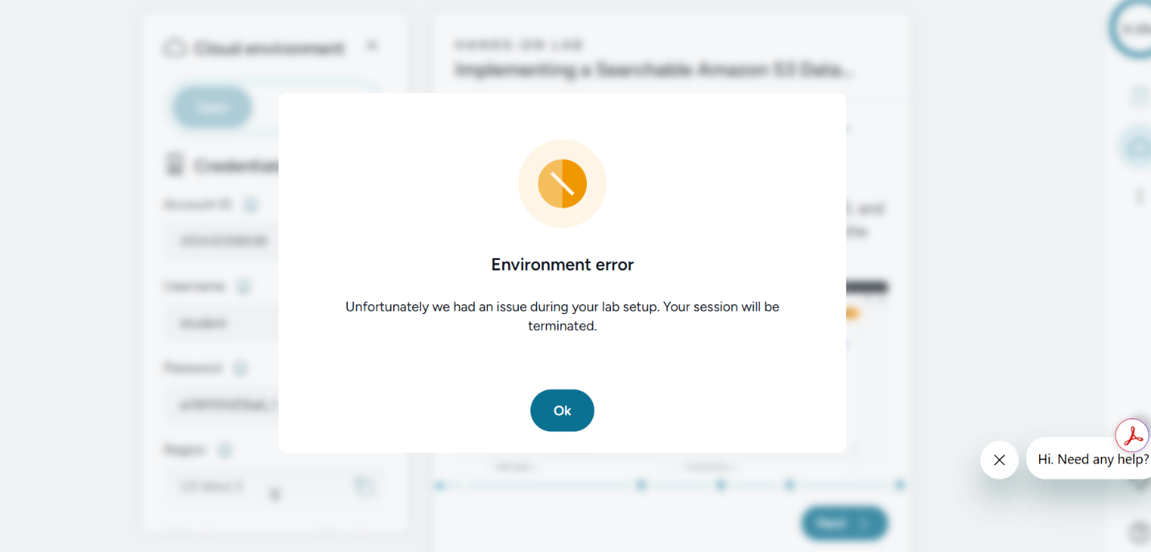

Implemented an AWS Lambda Function
Implemented an AWS Lambda function triggered by Amazon S3 object creation events to convert JSON files into Parquet files.

Created an Amazon EventBridge Rule
Created an Amazon EventBridge rule that is invoked when a new object is created in Amazon S3.

Added Partition Index
Added a partition index to an AWS Glue Table to increase processing efficiency.

Queried Amazon S3 Data Using Amazon Athena
Utilized Amazon Athena to run queries on the partitioned data generated from the event.

Questions
- What is AWS Glue and what functionalities can it perform?
AWS Glue is a fully serverless data integration and ETL (Extract, Transform, Load) service provided by Amazon Web Services. It is designed to help users discover, prepare, clean, transform, and move data across AWS services without managing infrastructure. AWS Glue is commonly used in data lake and analytics architectures

Key functionalities of AWS Glue include:
- Data Crawling & Cataloging: AWS Glue Crawlers automatically scan data stored in Amazon S3 and identify schemas, then store metadata (tables, columns, data types) in the AWS Glue Data Catalog, which acts as a centralized metadata repository.
- ETL Processing: AWS Glue provides serverless ETL jobs powered by Apache Spark that can transform data between formats, such as JSON to Parquet, using Python or Scala.
- Workflow Orchestration: Glue supports triggers and workflows to automate data pipelines and chain multiple ETL jobs together.
- Analytics Integration: The Glue Data Catalog integrates seamlessly with Amazon Athena, Amazon Redshift Spectrum, and Amazon EMR, enabling SQL-based queries on data stored in S3.

- How is AWS Lambda used within this lab?
In this lab, AWS Lambda is used as a serverless event-driven processing engine that automatically transforms data when new files are uploaded to Amazon S3.

Specifically:
- AWS Lambda is triggered by an Amazon S3 object creation event, meaning the function runs immediately when a new JSON file is added to the S3 bucket.
- The Lambda function reads the newly uploaded JSON file, processes and flattens the semi-structured data, and converts it into an optimized Parquet format.
- The transformed Parquet files are then written back to Amazon S3, making them ready for cataloging by AWS Glue and querying with Amazon Athena.

- What is the difference between denormalized JSON data and normalized Parquet data?
Denormalized JSON data and normalized Parquet data differ significantly in structure, performance, and analytics suitability.
- JSON (Denormalized Data):
  - JSON is a row-oriented, text-based, schema-less format that often contains deeply nested structures.
  - It is easy to ingest and flexible but inefficient for analytics due to large file sizes and the need to parse entire documents during queries.
  - JSON is best suited for raw data ingestion and landing zones in data lakes.
- Parquet (Normalized Data):
  - Parquet is a columnar, binary, schema-based format optimized for analytical workloads.
  - It supports compression, column pruning, and predicts pushdown, resulting in faster query performance and significantly reduced storage costs.
  - Parquet is ideal for processed, analytics-ready datasets queried using tools such as Amazon Athena and Apache Spark.

